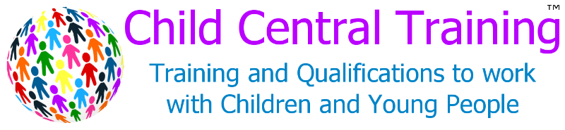
Internal Data Request
SQA Change of Course/Units

NOTE: For best results and to avoid delay in processing, this form can be downloaded from our website: www.childcentraltraining.co.uk/about/forms and completed on the computer and emailed to katrina@childcentraltraining.co.uk. If written out, the form should be completed using BLACK INK and BLOCK CAPITALS.

Form Completed by: | Date Submitted | Date Acted On  (For Office Use Only)
Click here to enter text. | Date | Date

Candidates are only registered with SQA once the class has 'settled' and the assessor believes that all remaining candidates will complete the course. This form needs to be completed by assessors and sent to Child Central Training. This form is just for individuals/groups who are doing the same units.

Class Information
Class Name on MOODLE | Year Started | Expected Completion Date (month/year)
Click here to enter text. | Click here to enter text. | Click here to enter text.

What Would You Like To Change
☐ SQA Group Code Registration
☐ SQA Unit Code Registration
Please Detail the Proposed Change
enter code.

Candidate Names
Name | SCN Number | Name |  | SCN Number
Click here to enter text. | SCN. |  | Click here to enter text. | SCN.
Click here to enter text. | SCN. |  | Click here to enter text. | SCN.
Click here to enter text. | SCN. |  | Click here to enter text. | SCN.
Click here to enter text. | SCN. |  | Click here to enter text. | SCN.
Click here to enter text. | SCN. |  | Click here to enter text. | SCN.
Click here to enter text. | SCN. |  | Click here to enter text. | SCN.

Additional Information
Click here to enter text.

Form Last Updated August 2017 by Alison Stewart

